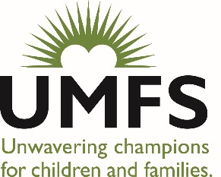

United Methodist Family Services
Offering Scripts

Following are scripts that help summarize the work of UMFS for your congregation. These can be used in a variety of ways: as a quick summary of UMFS before the offering, as a mission moment during the service, or as copy for your bulletin. You can also download a full color bulletin insert, short 1-minute UMFS videos, graphics and images, and other resources at UMFS.org/church.

UMFS Quick Summary
United Methodist Family Services is an unwavering champion for high-risk children and families in Virginia. UMFS serves children in foster care and children struggling with mental health and behavioral challenges. They provide foster care and adoptive programs, specialized education schools, and mental health programs. Your support of UMFS through this offering will help high-risk children achieve a brighter future. Thank you for supporting this transformative ministry.

UMFS Mission Moment
United Methodist Family Services is an unwavering champion for high-risk children and families in Virginia. UMFS serves children in foster care and children struggling with mental health and behavioral challenges. They provide foster care and adoptive programs, specialized education schools, and mental health programs. Your support of UMFS through this offering will help high-risk children achieve a brighter future.
Your financial gifts to UMFS through this offering will provide support to high-risk children and teens like Melvin.
When Melvin was 15, his life changed dramatically. He entered foster care. He was referred to UMFS, and got involved in the UMFS Project LIFE program. Project LIFE helps equip teens in foster care with critical life skills to help them become successful adults.
Melvin was skeptical at first, but over time he became one of Project LIFE’s most active members. He attended support groups, worked with a volunteer mentor, and took on leadership positions and speaking opportunities. The skills Melvin developed at UMFS helped him achieve a major life goal: college. Today, Melvin is proud to be a student at Old Dominion University. Thanks to the support of generous people like you, Melvin is on the road to a brighter future.
There are over 5,300 children and teens like Melvin in foster care in Virginia. Nationally, only 50% of youth in foster care complete high school by age 18, and less than 9% graduate from college.
You can give youth in foster care the same love and support that helped Melvin shatter these statistics. By supporting the work of UMFS, we become unwavering champions for children and teens like Melvin. Together, we can help restore hope, one child at a time.

