1320 Central Park Blvd Suite 310
Fredericksburg VA 22401
540.899.1773

Medicaid
Provider Directory

Introduction
This directory serves as a resource of medical providers with whom current and previous foster families have had good success in getting treatment for children in their care with Medicaid. If you know of a provider not listed, please email Susan Kosior at skosior@umfs.org with the provider’s information.
UMFS does not recommend any particular provider over any other; this list is simply providers used successfully by families in the past, or those providers who indicate a willingness to accept Medicaid patients. An asterisk (*) indicates that this provider has been recommended by one of our foster families. For more information or to do a provider search, visit the Medicaid website at www.dmas.virginia.gov (see instructions at the end of this directory).
Table of Contents
Pediatricians
Dentists
Therapists
Occupational/Physical Therapists
Urgent Care
Eye Care



Pediatricians
Company Name: | Kid’s Choice Pediatrics
Address Line 1: | 10411 Courthouse Road, Suite A
Address Line 2: | Spotsylvania VA 22553
Phone: | 540.710.6006
Fax: | 540.710.6001
Website Address: | Kidschoicepeds.net
Company Name: | Preferred Pediatrics*
Address Line 1: | 10600 Spotsylvania Ave Fredericksburg VA 22408
Address Line 2: | 331 Park Hill Drive Fredericksburg VA 22401
Location 3: | 9755 Courthouse Rd, Suite 101 Spotsylvania VA 22553
Phone: | 540.604.9500; 540.368.8901; 540.898.9680
Fax: | 540.604.9501; 540.368.8095; 540.898.9699
Website Address: | Mypreferredpediatrics.com
Company Name: | Pediatrics at Orange*
Address Line1: | 661 University Ln. Suite A
Address Line 2: | Orange VA 22960
Phone: | 540.661.3025
Fax: | 540.661.3021
Website Address: | http://uvahealth.com/locations/profile/orange-pediatrics
Company Name: | UVA Pediatrics Culpeper*
Address Line1: | 633 Sunset Ln, Suites A &C
Address Line 2: | Culpeper VA 22701
Phone: | 540.825.5381
Fax: | 540.829.0945
Website Address: | http://uvahealth.com/locations/profile/uva-pediatrics-culpeper

Company Name: | Kilby Pediatrics
Address Line 1: | 100 Saunders St.
Address Line 2: | Culpeper VA 22701
Phone: | 540.829.4900
Fax: | 540.829.4901
Website Address: | www.kilbypediatrics.com
Company Name: | Reese Medical Associates*
Address Line 1: | 10620 Spotsylvania Ave.
Address Line 2: | Fredericksburg VA 22408
Phone: | 540.374.3150
Fax: | 540.374.3151
Website Address: | http://www.marywashingtonhealthcare.com/mwmg-family-medicine-reese
Company Name: | Caroline Christian Health Center
Address Line1: | 17470 Center Dr Suite 4A
Address Line 2: | Ruther Glen VA 22546
Phone: | 804.448.1380
Fax:
Website Address: | http://www.cchcpeds.org
Company Name: | Pratt Medical Center (Drs. Goodlett and Simes)
Address Line1: | 4701 Spotsylvania Pkwy.
Address Line 2: | Fredericksburg VA 22407
Phone: | 540.834.5430
Fax:
Website Address: | http://prattmed.com/our-services/pediatrics/

Pediatricians
Company Name: | Kid’s Choice Pediatrics
Address Line 1: | 10411 Courthouse Road, Suite A
Address Line 2: | Spotsylvania VA 22553
Phone: | 540.710.6006
Fax: | 540.710.6001
Website Address: | Kidschoicepeds.net
Company Name: | Preferred Pediatrics
Address Line 1: | 10600 Spotsylvania Ave Fredericksburg VA 22408
Address Line 2: | 331 Park Hill Drive Fredericksburg VA 22401
Location 3: | 9755 Courthouse Rd, Suite 101 Spotsylvania VA 22553
Phone: | 540.604.9500; 540.368.8901; 540.898.9680
Fax: | 540.604.9501; 540.368.8095; 540.898.9699
Website Address: | Mypreferredpediatrics.com
Company Name: | Pediatrics at Orange*
Address Line1: | 661 University Ln. Suite A
Address Line 2: | Orange VA 22960
Phone: | 540.661.3025
Fax: | 540.661.3021
Website Address: | http://uvahealth.com/locations/profile/orange-pediatrics
Company Name: | UVA Pediatrics Culpeper*
Address Line1: | 633 Sunset Ln, Suites A &C
Address Line 2: | Culpeper VA 22701
Phone: | 540.825.5381
Fax: | 540.829.0945
Website Address: | http://uvahealth.com/locations/profile/uva-pediatrics-culpeper

Company Name: | Rappahannock Pediatric Associates
Address Line 1: | 2632 Salem Church Rd
Address Line 2: | Fredericksburg VA 22407
Phone: | 540.899.3430
Fax: | 540.899.3431
Website Address: | http://rappahannockpediatrics.com
Company Name: | Milestone Pediatric & Adolescent Care*
Address Line 1: | 7500 Iron Bar Lane, Ste 120 (VA Gateway Professional Bldg)
Address Line 2: | Gainesville, VA 20155
Phone: | 703.753.6772
Fax: | 1.888.972.4515
Website Address: | http://www.milestoneskids.com
Company Name: | Piedmont Pediatrics
Address Line1: | 20 Rock Pointe Lane
Address Line 2: | Warrenton, VA 20186
Phone: | 540.347.9900
Fax:
Website Address: | http://www.piedmontpediatrics.com
Company Name: | Warrenton Pediatrics
Address Line1: | 28 Blackwell Park Lane, Suite 103
Address Line 2: | Warrenton, VA 20186
Phone: | 540.349.3225
Fax:
Website Address: | http://www.warrentonpediatrics.com

Occupational Therapists
Company Name: | Fox Therapy Center
Address Line 1: | 321 Park Hill Dr
Address Line 2: | Fredericksburg VA 22401
Phone: | 540.446.2654
Fax: | 540.479.1407
Website Address: | www.foxtherapycenter.com
Company Name: | Helping Hands Inc
Address Line 1: | 2049 Jefferson Davis Hwy
Address Line 2: | Stafford VA 22554
Phone: | 540.657.1423
Fax: | 540.657.1424
Website Address: | www.hhitherapy.com
Company Name: | Sensational Kidz *
Address Line1: | 4528 Plank Rd.
Address Line 2: | Fredericksburg VA 22407
Phone: | 540.841.4443
Fax: | 703.563.7306
Website Address: | http://kidztherapy.org
Company Name:
Address Line1:
Address Line 2:
Phone:
Fax:
Website Address:

Dentists
Company Name: | Kool Smiles (Note: there is often a long wait time)
Address Line 1: | 3533 Plank Rd
Address Line 2: | Fredericksburg VA 22407
Phone: | 540.736.4918
Fax: | 540.786.1076
Website Address: | www.mykoolsmiles.com
Company Name: | Pediatric Dentistry of Fredericksburg*
Address Line 1: | 1300 Thornton St
Address Line 2: | Fredericksburg VA 22401
Phone: | 540.371.3222
Fax: | 540.371.9539
Website Address: | Fredericksburgpediatricdentist.com
Company Name: | Gainesville Pediatric Dentistry
Address Line1: | 13555 Wellington Circle, Suite 105
Address Line 2: | Gainesville VA 20155
Phone: | 703.754.1580
Fax: | 703.754.1897
Website Address: | Gpdsmile.com
Company Name: | Madison Family Dentistry*
Address Line1: | 306 S. Main St
Address Line 2: | Madison VA 22727
Phone: | 540.948.4488
Fax: | 540.948.4662
Website Address: | Madisonfamilydds.com

Company Name: | Fredericksburg Pediatric Dentistry & Orthodontics
Address Line 1: | 927 Maple Grove Drive
Address Line 2: | Fredericksburg, VA 22407
Phone: | 540.786.0051
Fax:
Website Address: | www.kakardentalgroup.com
Company Name: | Clear Care Dental (Pediatric Dentistry & Orthodontics)
Address Line 1: | 10 Chatham Heights Road
Address Line 2: | Fredericksburg, VA 22405
Phone: | 540.785.4494
Fax:
Website Address: | www.clearcaredental.com
Company Name: | Amazing Smile Dental Care (open 8:00 a.m. to 8:00 p.m.)
Address Line1: | 506 Fletcher Drive
Address Line 2: | Warrenton, VA 20186
Phone: | 540.216.3445
Fax:
Website Address: | www.warrentonamazingsmile.com
Company Name:
Address Line1:
Address Line 2:
Phone:
Fax:
Website Address:
Dentists

Therapists
Company Name: | Mindful Health – Shirley Bronston (ages 0-19)
Address Line 1: | 810 Westwood Office Park
Address Line 2: | Fredericksburg VA 22401
Phone: | 540.288.4769
Fax: | 484.845.6940
Website Address: | Mindfulhealthva.com
Company Name: | Intuitive Journeys PLC *
Address Line 1: | 500 Lafayette Blvd. Suite 130
Address Line 2: | Fredericksburg VA 22401
Phone: | 540.300.1564
Fax:
Website Address: | Intuitivejourneysplc.com
Company Name: | Phyllis Byrne*
Address Line1: | 13226 Lovers Ln
Address Line 2: | Culpeper VA 22701
Phone: | 540.829.9777
Fax:
Website Address:
Company Name: | Behavioral Care Services (ages 6-19)
Address Line1: | 7340 Heritage Village Plaza Suite 102
Address Line 2: | Gainesville VA 20155
Phone: | 540.425.3031
Fax: | 866.299.2424
Website Address: | www.behavioral-care.com

Therapists
Company Name: | Empowering Families Program – Dr. Daniel Price (ages 6-19)
Address Line 1: | 206 S. East St
Address Line 2: | Culpeper VA 22701
Phone: | 540.986.4459
Fax: | 540.829.6816
Website Address: | www.empoweringfamiliesprogram.com
Company Name: | Creative Counseling Studio (ages 4+)
Address Line 1: | 385 Garrisonville Rd, Suite 112
Address Line 2: | Stafford VA 22554
Phone: | 540.658.9122
Fax: | 540.658.9222
Website Address: | Creativecounseling.wix.com
Company Name: | Diane Bachman (ages 4+)
Address Line1: | 804 Charles St
Address Line 2: | Fredericksburg, VA 22401
Phone: | 540.845.7622
Fax: | 540.361.1557
Website Address: | www.centerforfamilycounseling.com
Company Name: | Mental Health Resources
Address Line1: | 412 Chatham Square Office Park
Address Line 2: | Fredericksburg VA 22405
Phone: | 540.899.9826
Fax: | 540.373.3913
Website Address: | www.mentalhealthresourcespc.com

Company Name: | Child & Family Psychology*
Address Line 1: | 310 Old Ivy Way Suite 104
Address Line 2: | Charlottesville VA 22908
Phone: | 434.243.6950
Fax: | 540.243.6970
Website Address: | http://uvahealth.com/locations/profile/Child-Family-Psychiatry-Clinic
Company Name: | Debra McPhee, LPC
Address Line 1: | 600 Jackson Street
Address Line 2: | Fredericksburg, VA 22401
Phone: | 540.373.6876
Fax:
Website Address:
Company Name: | Today’s Youth Services
Address Line1: | 10035 Sliding Hill Rd
Address Line 2: | Ashland VA 23005
Phone: | 804.368.8783
Fax: | 804.368.8784
Website Address: | http://www.tysinc.org
Company Name: | RACSB--Caroline County Clinic
Address Line1: | 19254 Rogers Clark Blvd
Address Line 2: | Ruther Glen, VA 22546
Phone: | 804.633.9997
Fax:
Website Address: | http://www.racsb.state.va.us/

Urgent Care
Company Name: | Aquia Family Medical Center (M-F 9-6; Saturday 9-2)
Address Line 1: | 2146 Jefferson Davis Highway #101
Address Line 2: | Stafford, VA 22554
Phone: | 540.657.9191
Fax:
Website Address: | www.aquiamedcenter.com
Company Name: | KidMed Stafford (M-F 2-10; Sat & Sun 11 -9)
Address Line 1: | 20 Doc Stone Road
Address Line 2: | Stafford VA 22556
Phone: | 540.602.7766
Fax: | 540.699.2382
Website Address: | www.kidmedva.com
Company Name: | PedsXpress Children’s Urgent Care (M-F 3-11; Sat-Sun 9-7)
Address Line1: | 2511 Salem Church Rd
Address Line 2: | Fredericksburg VA 22407
Phone: | 540.786.1200
Fax:
Website Address: | www.pcpedsxpress.com
Company Name: | Novant Health Express Care (M-F 7:30 to 7; Sat-Sun 7:30-5)
Address Line1: | 480 Fletcher Dr.
Address Line 2: | Warrenton VA 20186
Phone: | 571.284.1220
Fax:
Website Address: | http://novanthealth.org

Urgent Care
Company Name: | NextCare – Three Locations (M-F 8-8; Sat-Sun 8-4)
Location 1 | 330 White Oak Rd. Fredericksburg VA 22405
Location 2 | 15 South Gateway Dr. #101 Fredericksburg VA 22406
Location 3 | 5825 Plank Rd #105 Fredericksburg VA 22407
Phone: | 888.941.8237
Website Address: | http://www.nextcare.com
Company Name: | Primary and Urgent Care – Three Locations
Location1 | 4510 Plank Rd #200 Fredericksburg VA 22407
Location 2 | 10009 Southpoint Pkwy Fredericksburg VA 22407 (Massaponnax)
Location 3 | 231 Garrisonville Rd Suite 101 Stafford VA 22554
Fax: | 540.785.9900(F); 540.898.6600(M); 540.288.9888(S)
Website Address: | http://www.primaryandurgentcare.com
Company Name: | Nova Medical & Urgent Care (M-F 8-8; Sat-Sun 8-5)
Address Line1: | 6950 Piedmont Center Plaza
Address Line 2: | Gainesville, VA 20155
Phone: | 540.347.0400
Fax: | 703.734-9512
Website Address: | http://www.novamedgroup.com
Company Name: | Med Express
Address Line1: | 1420 South Main St
Address Line 2: | Culpeper VA 22701
Phone: | 540.825.2202
Fax: | 540.825.1106
Website Address: | http://www.medexpress.com

Vision Care
Company Name: | Access Eye Center
Address Line 1: | 4516 Plank Rd 22407 ; 110 Cambridge Street 22405
Address Line 2: | 2761 Jeff Davis Hwy, Stafford; 4701 Spotsylvania Pkwy 22408
Other locations: | 7961 Kings Highway King George
Phone: | 540.371.2020 number for all locations
Website Address: | www.accesseye.com
Company Name: | Lee Brock
Address Line 1: | 4304 Lafayette Blvd.
Address Line 2: | Fredericksburg VA 22408
Phone: | 540.891.4444
Fax:
Website Address:
Company Name:
Address Line1:
Address Line 2:
Phone:
Fax:
Website Address:
Company Name:
Address Line1:
Address Line 2:
Phone:
Fax:
Website Address:

Specialists
Company Name: | Allergy & Asthma Center of Fredericksburg
Address Line 1: | 1300 Thornton St Suite 200
Address Line 2: | Fredericksburg VA 22401
Phone: | 540.371.6810
Fax: | 540.371.9154
Website Address: | http://www.allergyasthmadoctors.com/
Company Name: | Dr. Scott Young, Child Psychiatrist at RACSB
Address Line 1: | 600 Jackson Street
Address Line 2: | Fredericksburg, VA 22401
Phone: | 540.373.3223
Fax: | 540.371.3753
Website Address:
Company Name:
Address Line1:
Address Line 2:
Phone:
Fax:
Website Address:
Company Name:
Address Line1:
Address Line 2:
Phone:
Fax:
Website Address:

If you would like to find out if a medical provider accepts Medicaid, please do the following:
1. Visit the DMAS website at http://www.dmas.virginia.gov/ and click “Search Services” in the side bar.
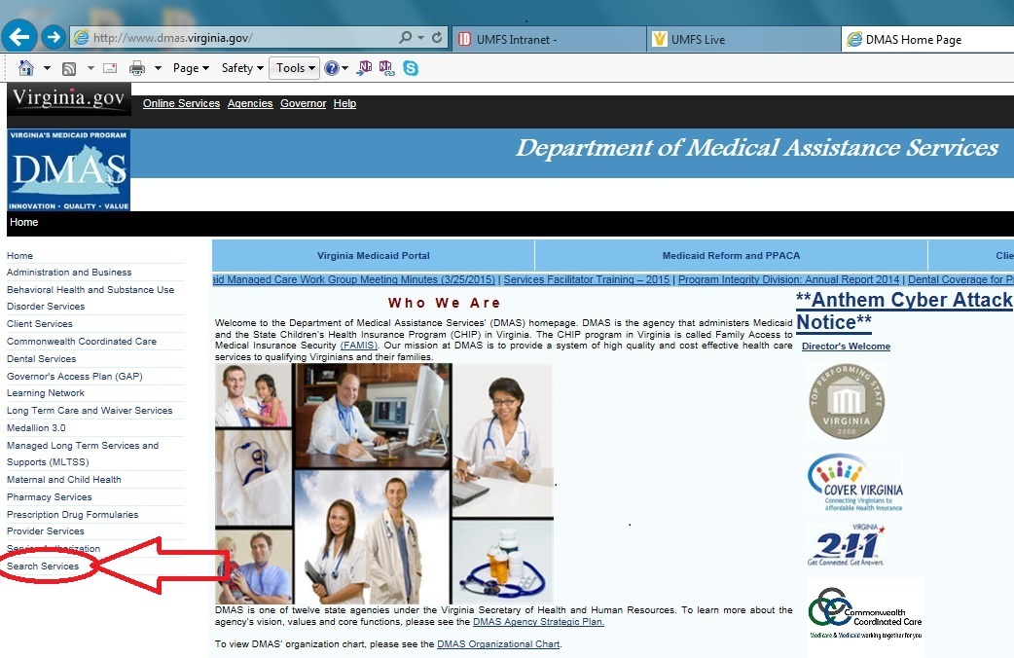

2. Select “Search for Providers” in the list provided
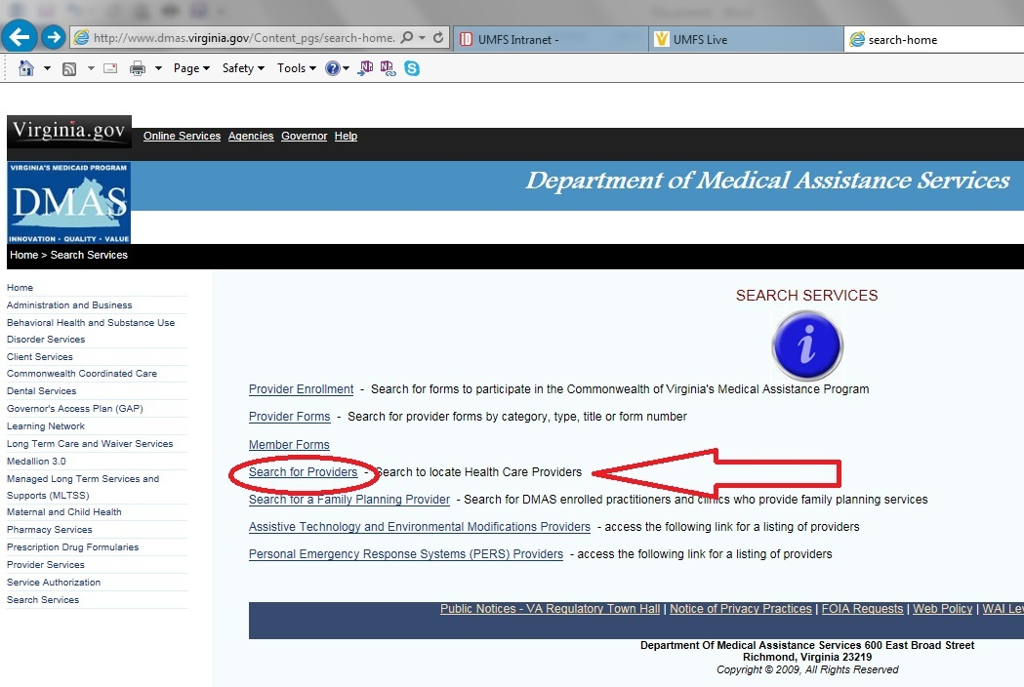

3. From the search page, you have three search options.
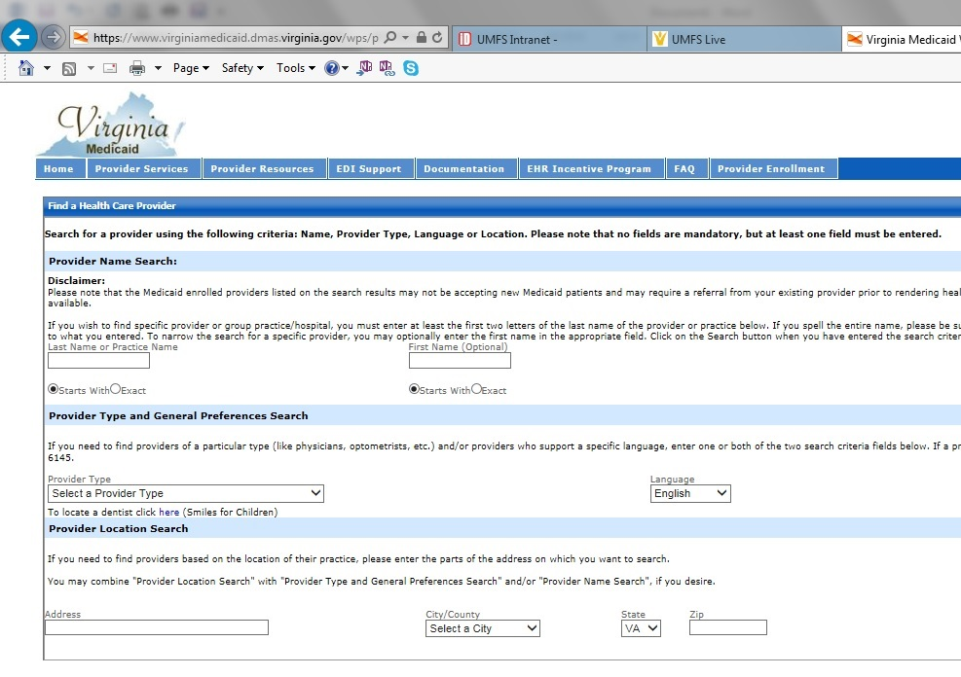
C
A
B

- To do a Provider Name Search, simply enter the doctor’s last name or the name of the practice in the search box. If you’re unsure of the spelling, try “Starts with” instead of “exact”, which requires the exact spelling of the doctor’s name.

- Provider Type: Choose what kind of provider you are looking for. If you are looking for a specific type of doctor, first choose physician, then choose the specialty (I.E. pediatrician).
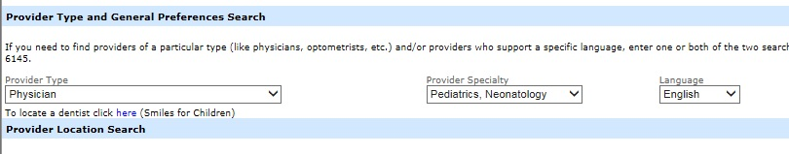

- Location Search: Search for a doctor based on your location. You can choose by city (i.e. Fredericksburg) or county (i.e. Stafford). All the providers in that location will come up alphabetically.

Once your search results come up, they will include the doctor’s contact information, their specialty, and what language(s) they speak.

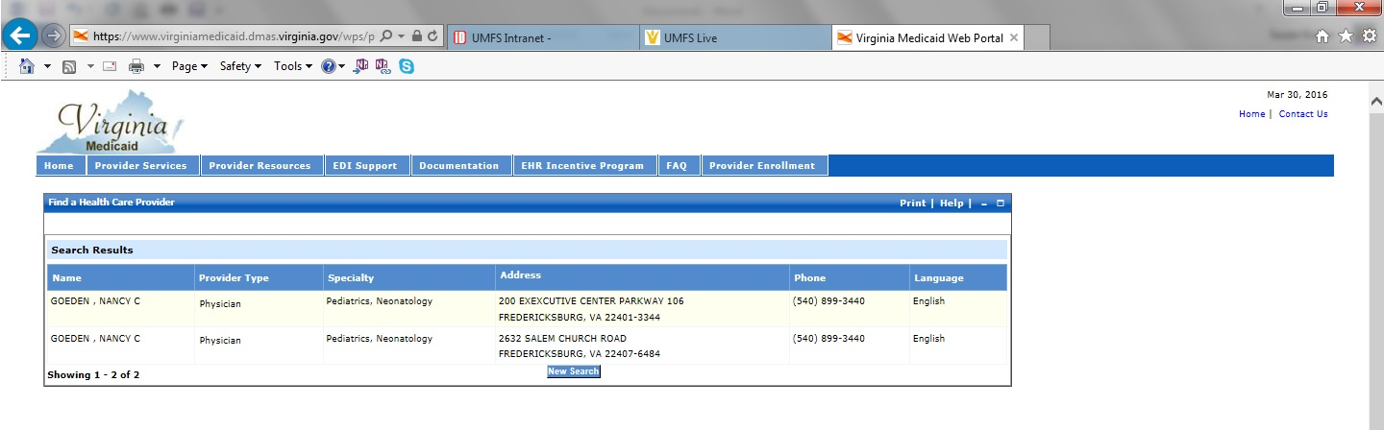
Note: You can combine fields to narrow your results. For instance, you can search a provider type and a location together to find providers in your area.

When in doubt, please call the doctor, and be sure to have your child’s Medicaid information handy to make sure that the doctor does in fact accept Medicaid.

